**Layout Techniques**

Layout techniques in CSS3 refer to various approaches and strategies used to arrange and position elements on a webpage, defining how they are structured and displayed.

These techniques play a crucial role in creating visually appealing and user-friendly layouts for websites.

CSS3 offers several powerful layout techniques that allow developers to achieve complex and flexible designs.

Some common layout techniques in CSS3 include:

1. **Floats**: Floats are a traditional CSS layout technique used to position elements horizontally within their parent container. Elements can be floated to the left or right, allowing other content to flow around them. Floats are commonly used for creating multi-column layouts and positioning elements side by side.
2. **Flexbox**: Flexbox is a modern CSS layout model that provides a more efficient way to arrange elements in a flexible and dynamic manner. With Flexbox, you can easily align and distribute elements along a single axis or multiple axes, making it ideal for creating responsive layouts and aligning items within containers.
3. **Grid**: CSS Grid Layout is a powerful layout system that allows developers to create two-dimensional grid-based layouts with ease. Grid layout enables precise control over the positioning and alignment of elements within rows and columns, making it suitable for complex and grid-based designs.
4. **Positioning**: CSS positioning allows developers to precisely position elements within the document flow or relative to their containing element. Positioning techniques include **static**, **relative**, **absolute**, and **fixed**, each offering different ways to control the placement of elements on the page.

By mastering these layout techniques in CSS3, developers can create flexible, responsive, and visually appealing layouts that enhance the user experience and effectively communicate information on the web.

**Floats**

The "floats" technique is a layout technique in CSS that allows elements to be positioned horizontally within their containing element.

When an element is floated, it is removed from the normal document flow and shifted to the left or right side of its containing element, with other content flowing around it.

Key aspects of the floats technique include:

1. **Float Property**: Elements are floated using the CSS **float** property, which can take one of the following values:
   * **float: left;**: Floats the element to the left side of its containing element.
   * **float: right;**: Floats the element to the right side of its containing element.
2. **Positioning**: Floated elements are positioned relative to the normal flow of the document. When an element is floated, it is taken out of the normal flow, allowing other elements to flow around it.
3. **Clearing Floats**: When floating elements, it's important to clear the float to prevent layout issues. Clearing the float ensures that elements following the floated element are positioned below it rather than alongside it. This can be achieved using the CSS **clear** property, commonly applied to elements following floated elements.
4. **Uses**: Floats are commonly used for creating multi-column layouts, positioning elements side by side, or wrapping text around images or other elements.
5. **Challenges**: While floats are versatile, they also come with challenges, such as clearing floats properly to prevent layout issues, maintaining equal column heights, and managing responsive layouts.

It's important to note that while floats have been widely used for layout in the past, newer layout techniques like Flexbox and CSS Grid have become more popular due to their more powerful and flexible capabilities.

However, floats are still used in certain situations, especially for supporting older browsers or for specific layout requirements.

**Example 01:**

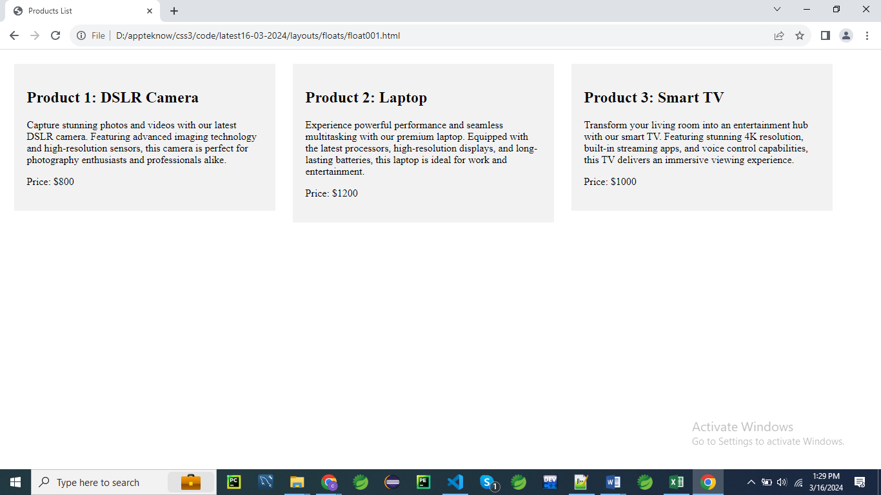

<!DOCTYPE html>

<html lang="en">

<head>

<meta charset="UTF-8">

<meta name="viewport" content="width=device-width, initial-scale=1.0">

<title>Products List</title>

<style>

    /* Apply CSS to create a simple multi-column layout using Floats */

    .container {

        width: 100%;

    }

    .column {

        float: left; /* Float elements to the left */

        width: 30%; /* Set width of each column */

        margin: 1%; /* Add margin between columns */

        background-color: #f2f2f2;

        padding: 20px;

        box-sizing: border-box; /* Include padding and border in width */

    }

</style>

</head>

<body>

<div class="container">

    <div class="column">

        <h2>Product 1: DSLR Camera</h2>

        <p>Capture stunning photos and videos with our latest DSLR camera. Featuring advanced imaging technology and high-resolution sensors, this camera is perfect for photography enthusiasts and professionals alike.</p>

        <p>Price: $800</p>

    </div>

    <div class="column">

        <h2>Product 2: Laptop</h2>

        <p>Experience powerful performance and seamless multitasking with our premium laptop. Equipped with the latest processors, high-resolution displays, and long-lasting batteries, this laptop is ideal for work and entertainment.</p>

        <p>Price: $1200</p>

    </div>

    <div class="column">

        <h2>Product 3: Smart TV</h2>

        <p>Transform your living room into an entertainment hub with our smart TV. Featuring stunning 4K resolution, built-in streaming apps, and voice control capabilities, this TV delivers an immersive viewing experience.</p>

        <p>Price: $1000</p>

    </div>

</div>

</body>

</html>

However if you change **float:right** in the css output should look like below

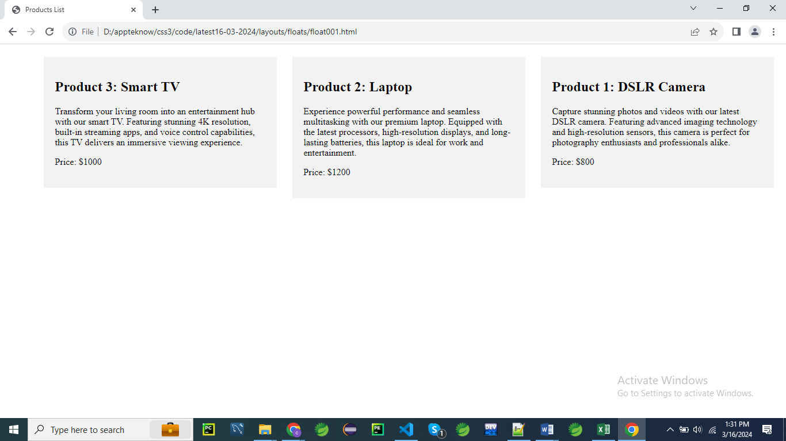

Here is a detailed explanation of the CSS rules for creating a simple multi-column layout using floats, with explanation points listed separately:

**Explanation:**

**.container {**

**width: 100%;**

**}**

**.container:**

1. **width: 100%;**
   * Sets the width of the .container to 100% of its parent element.
   * Ensures that the container spans the full width of its parent.
   * Provides a flexible layout that adjusts based on the width of the viewport or parent container.
   * Allows child elements (e.g., .column) to use the available space within the container.
   * Helps in creating a responsive layout where the container can expand or contract based on the screen size.

**.column {**

**float: left; /* Float elements to the left */**

**width: 30%; /* Set width of each column */**

**margin: 1%; /* Add margin between columns */**

**background-color: #f2f2f2;**

**padding: 20px;**

**box-sizing: border-box; /* Include padding and border in width */**

**}**

**.column:**

1. **float: left;**
   * Floats the .column elements to the left.
   * Allows multiple columns to be aligned next to each other horizontally.
   * Essential for creating a multi-column layout with float-based positioning.
   * Removes the column from the normal document flow, so other elements can wrap around it.
   * Requires clearing floats (e.g., using a clearfix) if there are other elements that follow the floated columns to ensure proper layout.
2. **width: 30%;**
   * Sets the width of each .column to 30% of the parent container's width.
   * Ensures that each column occupies 30% of the container's width, leaving space for margins.
   * Allows for a flexible layout where the columns adapt to the container’s size.
   * Provides space for multiple columns within the container.
   * Can be adjusted depending on the number of columns and desired spacing.
3. **margin: 1%;**
   * Adds a 1% margin around each .column.
   * Creates space between columns to prevent them from touching each other.
   * Margins help in separating columns visually and improving the layout's appearance.
   * The margin is based on the width of the parent container, making it responsive.
   * Margins do not affect the column's width, as the total width is calculated with respect to the width property.
4. **background-color: #f2f2f2;**
   * Sets the background color of the .column elements to #f2f2f2.
   * #f2f2f2 is a light gray color in hexadecimal format.
   * Provides a subtle background that contrasts with the content.
   * Enhances the visual separation of columns and improves readability.
   * Ensures a consistent appearance across different columns.
5. **padding: 20px;**
   * Adds 20 pixels of padding inside each .column.
   * Creates space between the column's content and its border.
   * Ensures that the content does not touch the edges of the column, improving readability.
   * Contributes to the overall layout and design of the column.
   * Padding affects the total size of the column due to the box-sizing: border-box property.
6. **box-sizing: border-box;**
   * Includes padding and border in the element's total width and height.
   * Ensures that the width specified for the .column includes padding and borders, avoiding overflow issues.
   * Makes it easier to manage layout dimensions and spacing.
   * Helps in creating a consistent layout by preventing the box from expanding beyond the specified width.
   * Simplifies the calculation of element sizes, especially in multi-column layouts.

By understanding these CSS rules, you can effectively create a multi-column layout using floats, managing spacing, alignment, and overall design of the columns within a container.

**Flexible Box Layout (Flexbox)**

Flexbox, short for **Flexible Box Layout**, is a layout model in CSS3 that provides a more efficient way to design and align items within a container, even when their size is unknown or dynamic.

It allows for the distribution of space within a container, as well as alignment, ordering, and sizing of its children (flex items).

Here's a basic overview of how Flexbox works:

1. **Container (Parent)**:

The container is a parent element that holds one or more flex items.

To enable Flexbox layout, you need to apply the **display: flex;** or **display: inline-flex;** property to the container element.

This property activates the flexbox layout mode.

1. **Flex Items (Children)**:

These are the elements inside the flex container.

By default, flex items will try to fit in a row direction.

However, you can control the layout using various Flexbox properties.

Here are some key properties you can use on the flex container (parent):

* **display**: **flex** or **inline-flex**.
* **flex-direction**: Specifies the direction of the main axis. It can be **row**, **row-reverse**, **column**, or **column-reverse**.
* **justify-content**: Aligns flex items along the main axis. Values include **flex-start**, **flex-end**, **center**, **space-between**, and **space-around**.
* **align-items**: Aligns flex items along the cross axis. Values include **flex-start**, **flex-end**, **center**, **baseline**, and **stretch**.
* **align-content**: Aligns flex lines along the cross axis. This property is only applicable if there are multiple lines of flex items. Values include **flex-start**, **flex-end**, **center**, **space-between**, **space-around**, and **stretch**.

And here are some key properties you can use on the flex items (children):

* **order**: Specifies the order in which flex items appear within the flex container.
* **flex-grow**: Specifies how much a flex item will grow relative to other flex items in the container.
* **flex-shrink**: Specifies how much a flex item will shrink relative to other flex items in the container.
* **flex-basis**: Specifies the initial size of a flex item.
* **flex**: A shorthand for **flex-grow**, **flex-shrink**, and **flex-basis**.
* **align-self**: Overrides the **align-items** value for a specific flex item.

Flexbox provides a powerful and intuitive way to create layouts in CSS, especially for dynamic and responsive designs. It simplifies many layout tasks that were previously complex or required hacks with other layout models like floats or positioning.

**display:flex**

The **display: flex** property in CSS is used to create a flexible layout that allows items within a container to be aligned and distributed efficiently, even when their sizes are unknown or dynamic.

It enables responsive designs, providing control over how items are spaced, aligned, and how they grow or shrink.

**Basic Concept**

When you apply display: flex to a container, it becomes a **flex container**, and its direct children become **flex items**.

The flex container controls the layout of its flex items.

**Syntax**

.container {

display: flex;

}

**Key Properties of Flexbox**

1. **Flex Container Properties**:
   * **flex-direction**: Defines the direction of the flex items (row, column, row-reverse, column-reverse).
   * **justify-content**: Aligns items along the main axis (left, right, center, space-between, space-around, space-evenly).
   * **align-items**: Aligns items along the cross axis (stretch, flex-start, flex-end, center, baseline).
   * **align-content**: Aligns rows of flex items when there's extra space in the cross axis (stretch, flex-start, flex-end, center, space-between, space-around).
   * **flex-wrap**: Controls whether flex items should wrap onto multiple lines (nowrap, wrap, wrap-reverse).
2. **Flex Item Properties**:
   * **flex-grow**: Defines the ability of a flex item to grow relative to the rest.
   * **flex-shrink**: Defines the ability of a flex item to shrink relative to the rest.
   * **flex-basis**: Defines the default size of an element before the remaining space is distributed.
   * **align-self**: Allows a single item to override the align-items value for its own alignment.

**Example: Basic Flexbox Layout**

<!DOCTYPE html>

<html lang="en">

<head>

<meta charset="UTF-8">

<meta name="viewport" content="width=device-width, initial-scale=1.0">

<title>Flexbox Example</title>

<style>

.container {

display: flex;

justify-content: space-between;

align-items: center;

height: 200px;

border: 2px solid #333;

background-color: #f9f9f9;

}

.item {

background-color: #4CAF50;

padding: 20px;

color: white;

font-size: 1.2em;

}

</style>

</head>

<body>

<div class="container">

<div class="item">Item 1</div>

<div class="item">Item 2</div>

<div class="item">Item 3</div>

</div>

</body>

</html>

**Explanation**

* **Container (.container)**:
  + display: flex: Turns the container into a flexbox container.
  + justify-content: space-between: Distributes the flex items (Item 1, Item 2, Item 3) evenly, with the first item aligned to the start, the last item aligned to the end, and the remaining space distributed evenly between the items.
  + align-items: center: Aligns the items **vertically** in the center of the container.
* **Items (.item)**:
  + Each flex item (Item 1, Item 2, Item 3) will be evenly spaced according to the justify-content and aligned **vertically** according to align-items.

**Result**

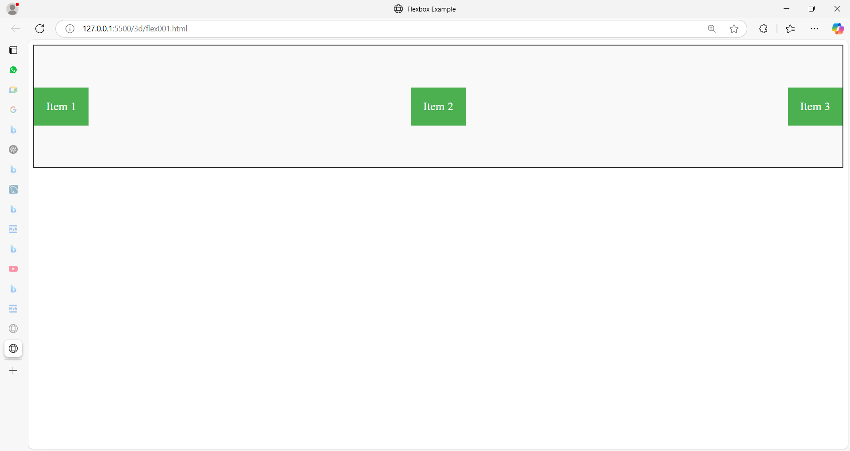

In this example, the flexbox container (.container) holds three items. The items are aligned horizontally with even space between them, and they are centered vertically within the container. This is just a simple demonstration of the flexibility and power of the Flexbox layout model.

**Flexbox Benefits**

* **Responsive Design**: Flexbox is excellent for responsive layouts because it allows items to grow, shrink, and wrap based on the available space.
* **Alignment**: Flexbox simplifies complex layouts that require specific alignment of items.
* **Order**: You can easily change the order of elements without changing the HTML structure, using the order property on flex items.

Flexbox is widely used in modern web development for creating versatile and responsive layouts.

**Example 01:**

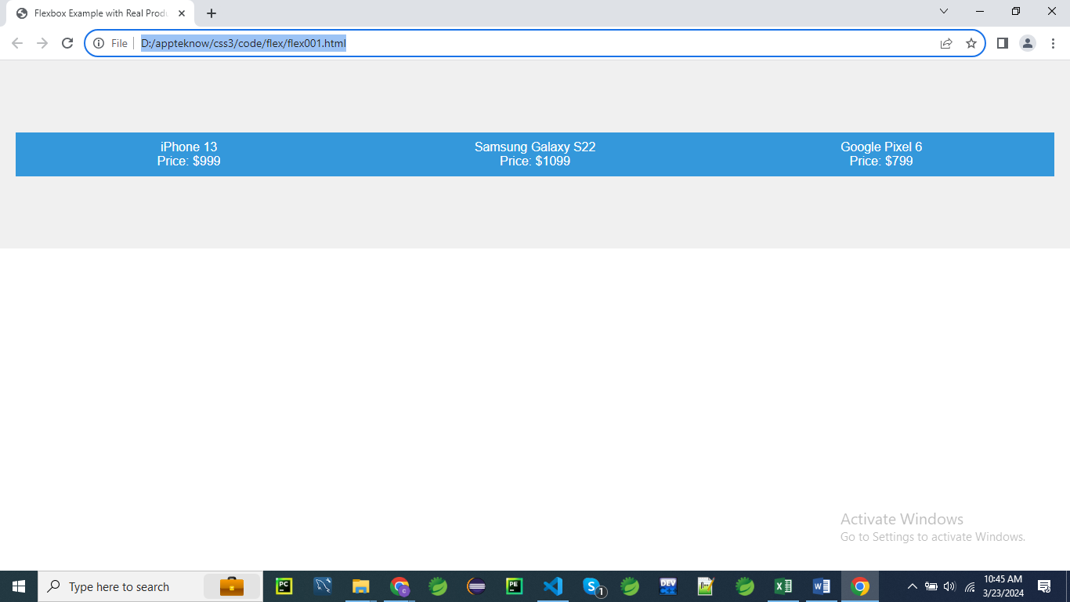

<!DOCTYPE html>

<html lang="en">

<head>

<meta charset="UTF-8">

<meta name="viewport" content="width=device-width, initial-scale=1.0">

<title>Flexbox Example with Real Product Names</title>

<style>

    /* CSS styles */

    .container {

        display: flex; /* Activate Flexbox layout for the container */

        justify-content: space-between; /* Align flex items with space between them */

        align-items: center; /* Align flex items vertically in the center */

        height: 200px; /* Set container height for visualization */

        background-color: #f0f0f0; /* Add a background color for visualization */

        padding: 20px; /* Add padding for spacing */

    }

    .item {

        flex: 1; /* Each flex item will take up equal space */

        padding: 10px; /* Add padding for spacing */

        background-color: #3498db;/* Set a background color for visualization */

        color: #fff; /* Set text color to white for better contrast */

        text-align: center; /* Center align text */

    }

    /* Additional styling for better visualization */

    body {

        font-family: Arial, sans-serif; /* Set a common font for better readability */

        margin: 0; /* Remove default margin */

        padding: 0; /* Remove default padding */

    }

</style>

</head>

<body>

    <!-- HTML structure -->

    <div class="container">

        <!-- Three flex items with real product names -->

        <div class="item">iPhone 13<br>Price: $999</div>

        <div class="item">Samsung Galaxy S22<br>Price: $1099</div>

        <div class="item">Google Pixel 6<br>Price: $799</div>

    </div>

</body>

</html>

**CSS Rules Explanation**

**.container:**

**.container {**

**display: flex; /* Activate Flexbox layout for the container */**

**justify-content: space-between; /* Align flex items with space between them */**

**align-items: center; /* Align flex items vertically in the center */**

**height: 200px; /* Set container height for visualization */**

**background-color: #f0f0f0; /* Add a background color for visualization */**

**padding: 20px; /* Add padding for spacing */**

**}**

1. **display: flex;**
   * Activates Flexbox layout for the .container element.
   * Enables a flexible box layout model that simplifies aligning and distributing space among items.
   * Makes the .container a flex container, allowing its child elements (flex items) to be arranged using Flexbox properties.
   * Allows for easy alignment and distribution of space within the container.
   * Ensures the container can manage its child elements' layout efficiently.
2. **justify-content: space-between;**
   * Aligns flex items with space distributed evenly between them.
   * Ensures the first item is flush with the start of the container, and the last item is flush with the end.
   * Distributes the available space between items, creating equal gaps.
   * Useful for layouts where equal spacing between items is desired.
   * Helps in creating a balanced and evenly spaced arrangement of flex items.
3. **align-items: center;**
   * Aligns flex items vertically in the center of the container.
   * Centers the items along the cross axis (vertical axis if the flex direction is row).
   * Ensures that items are positioned centrally within the container’s height.
   * Creates a visually balanced layout where items are aligned to the center.
   * Useful for aligning items within a container regardless of their height.
4. **height: 200px;**
   * Sets the height of the .container to 200 pixels.
   * Provides a fixed height for the container to visualize how items are aligned and spaced.
   * Helps in maintaining a consistent height for the container.
   * Useful for visualization purposes and layout adjustments.
   * Can be adjusted based on design requirements.
5. **background-color: #f0f0f0;**
   * Sets the background color of the .container to #f0f0f0.
   * #f0f0f0 is a light gray color in hexadecimal format.
   * Provides a subtle background color for better visualization of the container.
   * Helps in distinguishing the container area from other elements.
   * Ensures a consistent and visually appealing design.
6. **padding: 20px;**
   * Adds 20 pixels of padding inside the .container on all sides.
   * Creates space between the container’s border and its content.
   * Prevents content from touching the container’s edges, enhancing readability.
   * Contributes to a well-spaced and visually balanced layout.
   * Padding affects the container’s total size by expanding its box model.

**.item:**

**.item {**

**flex: 1; /* Each flex item will take up equal space */**

**padding: 10px; /* Add padding for spacing */**

**background-color: #3498db; /* Set a background color for visualization */**

**color: #fff; /* Set text color to white for better contrast */**

**text-align: center; /* Center align text */**

**}**

1. **flex: 1;**
   * Allows each .item to take up equal space within the .container.
   * Distributes available space equally among flex items.
   * Ensures that all items grow and shrink equally based on the container’s size.
   * Simplifies layout management by making items responsive to changes in container size.
   * Helps in creating a consistent layout where all items share the same width.
2. **padding: 10px;**
   * Adds 10 pixels of padding inside each .item on all sides.
   * Creates space between the item’s content and its border.
   * Ensures content does not touch the edges of the item, improving readability.
   * Contributes to the overall design and visual appeal of each item.
   * Padding affects the item’s total size due to the box-sizing: border-box property, if used.
3. **background-color: #3498db;**
   * Sets the background color of each .item to #3498db.
   * #3498db is a bright blue color in hexadecimal format.
   * Provides a distinctive background color for visualization and differentiation.
   * Enhances the visual appeal of each item within the container.
   * Ensures a consistent look across all items.
4. **color: #fff;**
   * Sets the text color within each .item to #fff.
   * #fff is white in hexadecimal format.
   * Provides high contrast against the blue background, enhancing readability.
   * Applies to all text within the .item.
   * Ensures the text is clear and easy to read against the background color.
5. **text-align: center;**
   * Centers text horizontally within each .item.
   * Applies to inline content, such as text and inline-block elements.
   * Creates a balanced and organized look for the text within the items.
   * Ensures that text is aligned centrally, which can be visually appealing.
   * Useful for items where central alignment of content is desired for symmetry.

**body:**

**body {**

**font-family: Arial, sans-serif; /* Set a common font for better readability */**

**margin: 0; /* Remove default margin */**

**padding: 0; /* Remove default padding */**

**}**

1. **font-family: Arial, sans-serif;**
   * Sets the font family for the entire body of the document.
   * Uses Arial as the primary font.
   * Falls back to a generic sans-serif font if Arial is unavailable.
   * Ensures a consistent text appearance across different devices and browsers.
   * Affects all text content within the body.
2. **margin: 0;**
   * Removes any default margin around the body element.
   * Ensures there is no extra space outside the body content.
   * Sets a clean edge for the body content.
   * Provides a consistent starting point for layout adjustments.
   * Helps in achieving a full-width layout without unwanted space.
3. **padding: 0;**
   * Removes any default padding inside the body element.
   * Ensures there is no extra space inside the body content.
   * Sets a clean edge for the body content.
   * Helps in achieving a full-width layout without unwanted space.
   * Provides a consistent starting point for layout adjustments.

This detailed explanation covers how each CSS rule contributes to the layout and styling of the .container and .item elements, as well as the overall body of the document.

**Explanation:**

* The **.container** class is set as a flex container using **display: flex;**. This means its children will follow the Flexbox layout rules.
* **justify-content: space-between;** is applied to **.container**, which will evenly distribute the flex items along the main axis with space between them.
* **align-items: center;** is applied to **.container**, which will align the flex items vertically in the center along the cross axis.
* Each flex item with the class **.item** has **flex: 1;** applied, which means they will grow and shrink equally to fill the available space.
* Additional styles are applied for visualization, including background colors, padding, and text alignment.

**What do you mean by flex: 1?**

In CSS Flexbox, the **flex** property is a shorthand property for setting three individual properties: **flex-grow**, **flex-shrink**, and **flex-basis**.

* **flex-grow**: The flex item will grow and take up available space along the main axis if necessary. In this case, **flex-grow** is set to **1**, which means the flex item will grow proportionally to other flex items in the container.
* **flex-shrink**: The flex item can shrink if necessary. It is also set to **1** by default, allowing the item to shrink if the container is too small.
* **flex-basis**: Specifies the initial size of the flex item before it grows or shrinks. When **flex: 1;** is used, **flex-basis** is set to **0%**, which allows the flex item to fill any remaining space in the container after other flex items have been laid out.

**Example 02:**

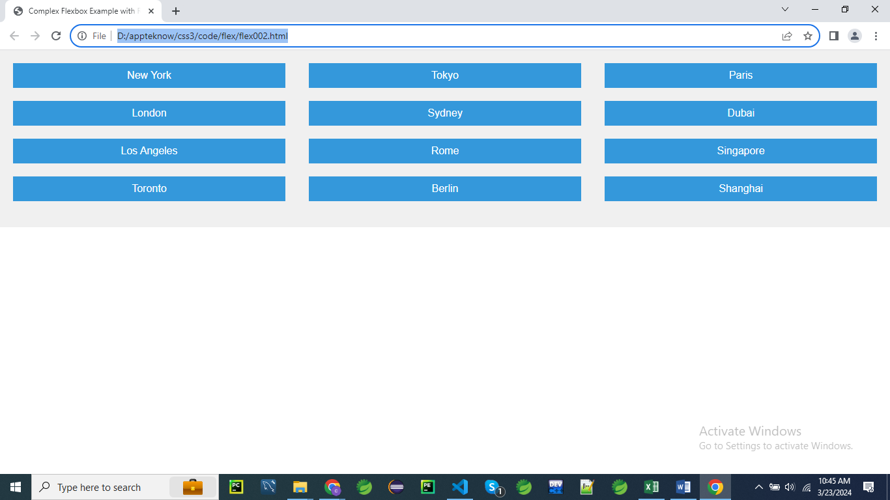

<!DOCTYPE html>

<html lang="en">

<head>

<meta charset="UTF-8">

<meta name="viewport" content="width=device-width, initial-scale=1.0">

<title>Complex Flexbox Example with Real Content</title>

<style>

    /* CSS styles */

    .container {

        display: flex; /* Activate Flexbox layout for the container */

        flex-wrap: wrap; /* Allow flex items to wrap onto multiple lines */

        justify-content: space-between; /* Align flex items with space between them */

        align-items: flex-start; /* Align flex items vertically at the start */

        height: auto; /* Set container height to auto for dynamic sizing */

        background-color: #f0f0f0; /* Add a background color for visualization */

        padding: 20px; /* Add padding for spacing */

    }

    .item {

        flex: 0 0 30%; /* Each flex item will take up 30% of the container width initially and won't grow or shrink */

        margin-bottom: 20px; /* Add margin between flex items */

        padding: 10px; /* Add padding for spacing */

        background-color: #3498db; /* Set a background color for visualization */

        color: #fff; /* Set text color to white for better contrast */

        text-align: center; /* Center align text */

    }

    /* Additional styling for better visualization */

    body {

        font-family: Arial, sans-serif; /* Set a common font for better readability */

        margin: 0; /* Remove default margin */

        padding: 0; /* Remove default padding */

    }

</style>

</head>

<body>

    <!-- HTML structure -->

    <div class="container">

        <!-- Several flex items with different content -->

        <div class="item">New York</div>

        <div class="item">Tokyo</div>

        <div class="item">Paris</div>

        <div class="item">London</div>

        <div class="item">Sydney</div>

        <div class="item">Dubai</div>

        <div class="item">Los Angeles</div>

        <div class="item">Rome</div>

        <div class="item">Singapore</div>

        <div class="item">Toronto</div>

        <div class="item">Berlin</div>

        <div class="item">Shanghai</div>

    </div>

</body>

</html>

**CSS Rules Explanation**

**.container:**

**.container {**

**display: flex; /* Activate Flexbox layout for the container */**

**flex-wrap: wrap; /* Allow flex items to wrap onto multiple lines */**

**justify-content: space-between; /* Align flex items with space between them */**

**align-items: flex-start; /* Align flex items vertically at the start */**

**height: auto; /* Set container height to auto for dynamic sizing */**

**background-color: #f0f0f0; /* Add a background color for visualization */**

**padding: 20px; /* Add padding for spacing */**

**}**

1. **display: flex;**
   * Activates the Flexbox layout model for the .container element.
   * Enables flexible box layout, allowing child elements (flex items) to be arranged using Flexbox properties.
   * Makes the .container a flex container.
   * Facilitates easy alignment and distribution of space among items.
   * Provides a flexible and responsive layout mechanism.
2. **flex-wrap: wrap;**
   * Allows flex items to wrap onto multiple lines if necessary.
   * Ensures that items will wrap to the next line when they exceed the container's width.
   * Helps in creating a responsive layout where items adapt to different screen sizes.
   * Prevents overflow and maintains a clean layout by wrapping items as needed.
   * Useful for handling various numbers of items in a responsive design.
3. **justify-content: space-between;**
   * Aligns flex items with space distributed evenly between them.
   * Ensures that the first item is flush with the start and the last item is flush with the end of the container.
   * Distributes the available space between items, creating equal gaps.
   * Useful for creating a balanced and evenly spaced arrangement of items.
   * Provides a clean and organized layout with consistent spacing.
4. **align-items: flex-start;**
   * Aligns flex items vertically at the start of the container.
   * Ensures that all items align along the top edge of the container (if flex direction is row).
   * Creates a consistent starting point for items vertically.
   * Helps in maintaining a clean and organized vertical alignment.
   * Useful when items need to be aligned at the top of the container.
5. **height: auto;**
   * Sets the container's height to auto, allowing it to adjust based on its content.
   * Ensures the container expands or contracts dynamically to fit the content inside.
   * Provides flexibility for the container’s height to be determined by the content and layout.
   * Helps in creating a responsive design where the container adapts to varying amounts of content.
   * Ensures that the container’s height is not fixed and adjusts as needed.
6. **background-color: #f0f0f0;**
   * Sets the background color of the .container to #f0f0f0.
   * #f0f0f0 is a light gray color in hexadecimal format.
   * Provides a subtle background color for better visualization and differentiation.
   * Helps in distinguishing the container area from other elements.
   * Enhances the overall design by providing a consistent background color.
7. **padding: 20px;**
   * Adds 20 pixels of padding inside the .container on all sides.
   * Creates space between the container’s border and its content.
   * Ensures that the content does not touch the edges of the container, improving readability.
   * Contributes to a well-spaced and visually balanced layout.
   * Padding affects the container’s total size by expanding its box model.

**.item:**

**.item {**

**flex: 0 0 30%; /* Each flex item will take up 30% of the container width initially and won't grow or shrink */**

**margin-bottom: 20px; /* Add margin between flex items */**

**padding: 10px; /* Add padding for spacing */**

**background-color: #3498db; /* Set a background color for visualization */**

**color: #fff; /* Set text color to white for better contrast */**

**text-align: center; /* Center align text */**

**}**

1. **flex: 0 0 30%;**
   * Defines the flex item's **flex**-**grow**, **flex**-**shrink**, and **flex**-**basis** properties.
   * 0 0 30% means:
     + flex-grow: 0: The item will not grow relative to other items.
     + flex-shrink: 0: The item will not shrink relative to other items.
     + flex-basis: 30%: The item will initially take up 30% of the container's width.
   * Ensures that each item occupies 30% of the container's width.
   * Prevents items from growing or shrinking, maintaining consistent widths.
   * Useful for creating a layout with fixed-width items that adapt to the container’s size.
2. **margin-bottom: 20px;**
   * Adds a 20-pixel margin at the bottom of each .item.
   * Creates space between flex items vertically.
   * Ensures that items do not touch each other, improving the layout’s appearance.
   * Contributes to a clean and organized look by separating items.
   * Useful for visual spacing between items in a multi-row layout.
3. **padding: 10px;**
   * Adds 10 pixels of padding inside each .item on all sides.
   * Creates space between the item’s content and its border.
   * Ensures that the content does not touch the edges of the item, enhancing readability.
   * Contributes to the item’s overall design and visual appeal.
   * Padding affects the item’s total size due to the box-sizing: border-box property, if used.
4. **background-color: #3498db;**
   * Sets the background color of each .item to #3498db.
   * #3498db is a bright blue color in hexadecimal format.
   * Provides a distinct background color for visualization and differentiation.
   * Enhances the visual appeal of each item within the container.
   * Ensures a consistent look across all items.
5. **color: #fff;**
   * Sets the text color within each .item to #fff.
   * #fff is white in hexadecimal format.
   * Provides high contrast against the blue background, improving readability.
   * Applies to all text within the .item.
   * Ensures the text is clear and easy to read against the background color.
6. **text-align: center;**
   * Centers text horizontally within each .item.
   * Applies to inline content, such as text and inline-block elements.
   * Creates a balanced and organized look for the text within the items.
   * Ensures that text is aligned centrally, which can be visually appealing.
   * Useful for items where central alignment of content is desired for symmetry.

**body:**

**body {**

**font-family: Arial, sans-serif; /* Set a common font for better readability */**

**margin: 0; /* Remove default margin */**

**padding: 0; /* Remove default padding */**

**}**

1. **font-family: Arial, sans-serif;**
   * Sets the font family for the entire body of the document.
   * Uses Arial as the primary font.
   * Falls back to a generic sans-serif font if Arial is unavailable.
   * Ensures a consistent text appearance across different devices and browsers.
   * Affects all text content within the body.
2. **margin: 0;**
   * Removes any default margin around the body element.
   * Ensures there is no extra space outside the body content.
   * Sets a clean edge for the body content.
   * Provides a consistent starting point for layout adjustments.
   * Helps achieve a full-width layout without unwanted space.
3. **padding: 0;**
   * Removes any default padding inside the body element.
   * Ensures there is no extra space inside the body content.
   * Sets a clean edge for the body content.
   * Helps achieve a full-width layout without unwanted space.
   * Provides a consistent starting point for layout adjustments.

This explanation provides a comprehensive understanding of each CSS rule and how they contribute to creating a responsive, visually appealing layout using Flexbox.

**In this example:**

* **.container** is a flex container with **flex-wrap: wrap;**, allowing flex items to wrap onto multiple lines if needed.
* **.item** class is applied to each flex item with **flex: 0 0 30%;**, meaning each item initially takes up 30% of the container width, won't grow, and won't shrink.
* Additional styling is added for better visualization, including margin between flex items.

This layout demonstrates a more complex Flexbox example with multiple rows of flex items, each having different flex properties.

**display:inline-flex**

The **display: inline-flex** property in CSS is similar to **display: flex** but with a key difference in how the flex container itself behaves in the document flow.

**Key Differences Between flex and inline-flex**

* **display: flex**:
  + The flex container behaves as a **block-level** element.
  + This means it takes up the full width available (by default), similar to a <div>, and starts on a new line.
* **display: inline-flex**:
  + The flex container behaves as an **inline-level** element.
  + This means it only takes up as much width as its content requires and allows other inline elements to sit next to it, similar to a <span> or <img>.

**Syntax**

.container {

display: inline-flex;

}

**Example: Inline Flexbox Layout**

<!DOCTYPE html>

<html lang="en">

<head>

<meta charset="UTF-8">

<meta name="viewport" content="width=device-width, initial-scale=1.0">

<title>Inline Flexbox Example</title>

<style>

.container {

display: inline-flex;

justify-content: space-around;

align-items: center;

border: 2px solid #333;

padding: 10px;

background-color: #f9f9f9;

}

.item {

background-color: #4CAF50;

padding: 10px;

color: white;

font-size: 1.2em;

margin: 5px;

}

</style>

</head>

<body>

<p>

Here is some text before the flexbox.

<span class="container">

<span class="item">Item 1</span>

<span class="item">Item 2</span>

<span class="item">Item 3</span>

</span>

And here is some text after the flexbox.

</p>

</body>

</html>

**Explanation**

* **Container (.container)**:
  + display: inline-flex: The container will only take up as much width as necessary to fit its contents (the flex items), and it will remain in line with any surrounding inline content.
  + justify-content: space-around: Distributes the flex items evenly with space around them.
  + align-items: center: Aligns the items vertically in the center of the container.
  + Since the container is inline, it can appear alongside other text or inline elements.
* **Items (.item)**:
  + Each flex item (Item 1, Item 2, Item 3) is evenly spaced and centered vertically within the inline flex container.

**Result**

In this example, the flexbox container is placed inline within a paragraph (<p>), between some text. The container itself does not break the flow of text, and the text appears on the same line, before and after the flexbox container.

**Use Cases for inline-flex**

* **Navigation Menus**: Inline flex containers are useful for creating horizontal navigation menus where the menu itself doesn't need to occupy the full width.
* **Inline Form Elements**: You can use inline-flex to align form elements such as input fields and buttons in a line without breaking the flow of surrounding text.
* **Icon and Text Alignment**: Aligning icons and text together inline can be easily managed with inline-flex.

inline-flex is powerful when you want the benefits of flexbox layout for a specific part of your content, but you need it to behave like an inline element in the document flow.

**Example 01**

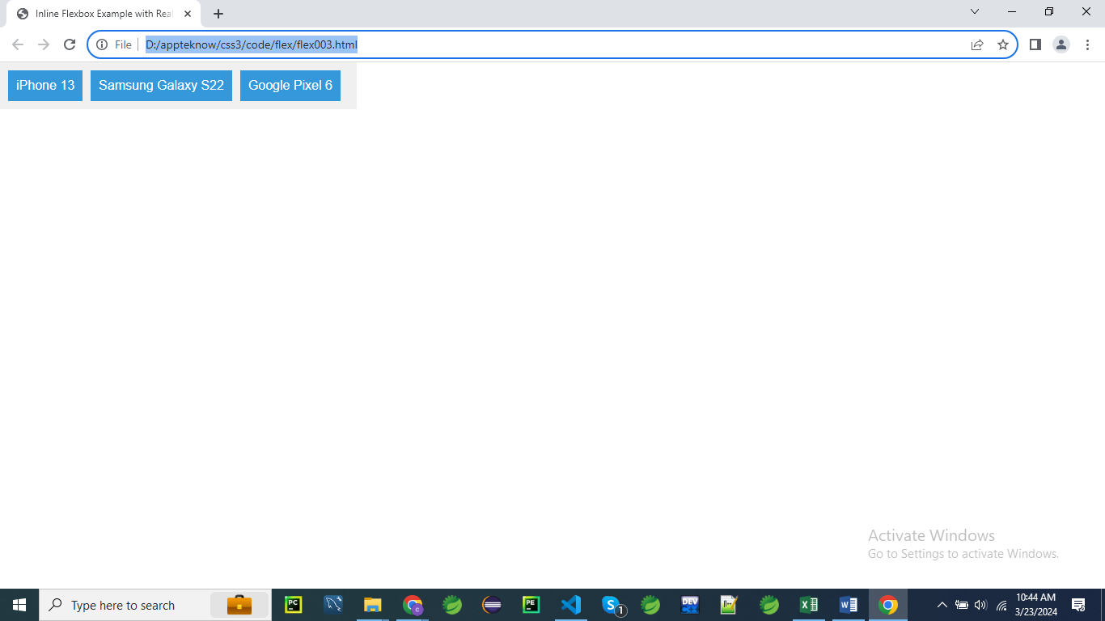

<!DOCTYPE html>

<html lang="en">

<head>

<meta charset="UTF-8">

<meta name="viewport" content="width=device-width, initial-scale=1.0">

<title>Inline Flexbox Example with Real Content</title>

<style>

    /* CSS styles */

    .container {

        display: inline-flex; /* Activate Inline Flexbox layout for the container */

        background-color: #f0f0f0; /* Add a background color for visualization */

        padding: 10px; /* Add padding for spacing */

    }

    .item {

        padding: 10px; /* Add padding for spacing */

        background-color: #3498db; /* Set a background color for visualization */

        color: #fff; /* Set text color to white for better contrast */

        text-align: center; /* Center align text */

        margin-right: 10px; /* Add margin between flex items */

    }

    /* Additional styling for better visualization */

    body {

        font-family: Arial, sans-serif; /* Set a common font for better readability */

        margin: 0; /* Remove default margin */

        padding: 0; /* Remove default padding */

    }

</style>

</head>

<body>

    <!-- HTML structure -->

    <div class="container">

        <!-- Flex items with real content -->

        <div class="item">iPhone 13</div>

        <div class="item">Samsung Galaxy S22</div>

        <div class="item">Google Pixel 6</div>

    </div>

</body>

</html>

**CSS Rules Explanation**

**.container:**

**.container {**

**display: inline-flex; /* Activate Inline Flexbox layout for the container */**

**background-color: #f0f0f0; /* Add a background color for visualization */**

**padding: 10px; /* Add padding for spacing */**

**}**

1. **display: inline-flex;**
   * Activates the Inline Flexbox layout for the .container.
   * The inline-flex value makes the .container behave like an inline element while using Flexbox layout rules.
   * Allows the container to align with other inline elements on the same line.
   * The container will only take up as much width as its content, unless otherwise constrained.
   * Facilitates flexible and inline layout for child elements within the container.
2. **background-color: #f0f0f0;**
   * Sets the background color of the .container to #f0f0f0.
   * #f0f0f0 is a light gray color in hexadecimal format.
   * Provides a neutral backdrop for the container’s content, enhancing visualization.
   * Helps distinguish the container area from other parts of the layout.
   * Ensures a consistent look across different devices and browsers.
3. **padding: 10px;**
   * Adds 10 pixels of padding inside the .container on all sides.
   * Creates space between the container’s border and its content.
   * Prevents content from touching the container’s edges, improving readability.
   * Contributes to a well-spaced and visually balanced layout.
   * Padding affects the container’s total size by expanding its box model.

**.item:**

**.item {**

**padding: 10px; /* Add padding for spacing */**

**background-color: #3498db; /* Set a background color for visualization */**

**color: #fff; /* Set text color to white for better contrast */**

**text-align: center; /* Center align text */**

**margin-right: 10px; /* Add margin between flex items */**

**}**

1. **padding: 10px;**
   * Adds 10 pixels of padding inside each .item on all sides.
   * Creates space between the item’s content and its border.
   * Prevents content from touching the item’s edges, enhancing readability.
   * Contributes to the item’s overall design and visual appeal.
   * Padding affects the item’s total size due to the box-sizing: border-box property, if used.
2. **background-color: #3498db;**
   * Sets the background color of each .item to #3498db.
   * #3498db is a bright blue color in hexadecimal format.
   * Provides a distinct background color for visualization and differentiation.
   * Enhances the visual appeal of each item within the container.
   * Ensures a consistent look across all items.
3. **color: #fff;**
   * Sets the text color within each .item to #fff.
   * #fff is white in hexadecimal format.
   * Provides high contrast against the blue background, improving readability.
   * Applies to all text within the .item.
   * Ensures the text is clear and easy to read against the background color.
4. **text-align: center;**
   * Centers text horizontally within each .item.
   * Applies to inline content, such as text and inline-block elements.
   * Creates a balanced and organized look for the text within the items.
   * Ensures that text is aligned centrally, which can be visually appealing.
   * Useful for items where central alignment of content is desired for symmetry.
5. **margin-right: 10px;**
   * Adds a 10-pixel margin to the right of each .item.
   * Creates space between flex items horizontally.
   * Ensures that items do not touch each other, improving the layout’s appearance.
   * Contributes to a clean and organized look by separating items.
   * Useful for providing spacing between items in a row layout.

**body:**

**body {**

**font-family: Arial, sans-serif; /* Set a common font for better readability */**

**margin: 0; /* Remove default margin */**

**padding: 0; /* Remove default padding */**

**}**

1. **font-family: Arial, sans-serif;**
   * Sets the font family for the entire body of the document.
   * Uses Arial as the primary font.
   * Falls back to a generic sans-serif font if Arial is unavailable.
   * Ensures a consistent text appearance across different devices and browsers.
   * Affects all text content within the body.
2. **margin: 0;**
   * Removes any default margin around the body element.
   * Ensures there is no extra space outside the body content.
   * Sets a clean edge for the body content.
   * Provides a consistent starting point for layout adjustments.
   * Helps achieve a full-width layout without unwanted space.
3. **padding: 0;**
   * Removes any default padding inside the body element.
   * Ensures there is no extra space inside the body content.
   * Sets a clean edge for the body content.
   * Helps achieve a full-width layout without unwanted space.
   * Provides a consistent starting point for layout adjustments.

This detailed explanation should give you a clear understanding of how each CSS rule contributes to creating a responsive, visually appealing layout using Inline Flexbox

**Explanation:**

* **.container** class has **display: inline-flex;**, which activates inline Flexbox layout for the container.
* This means the container will behave like an inline-level element, and its children will be laid out in a flex container inline with the text flow.
* **.item** class represents each flex item. These items are displayed inline due to the parent being an inline flex container.
* Each item has padding, background color, text color, and center-aligned text for better visualization.
* Additional styling includes setting a common font for readability, removing default margin and padding from the body, and adding spacing between flex items.

This example showcases how to use **display: inline-flex;** to create a flex container that behaves inline with text content.

**Example 02:**

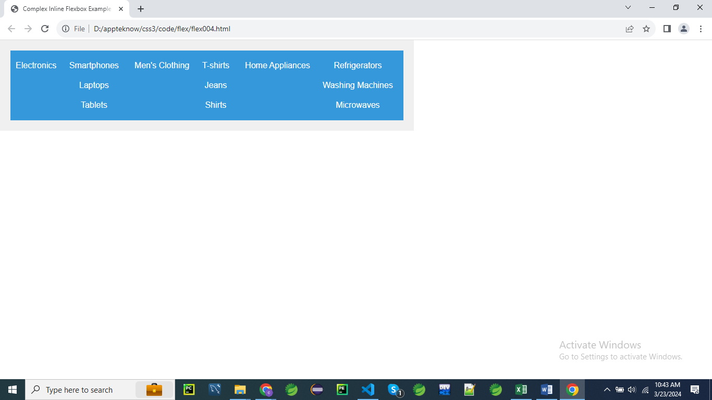

<!DOCTYPE html>

<html lang="en">

<head>

<meta charset="UTF-8">

<meta name="viewport" content="width=device-width, initial-scale=1.0">

<title>Complex Inline Flexbox Example with Realistic Content</title>

<style>

    /* CSS styles */

    .container {

        display: inline-flex; /* Activate Inline Flexbox layout for the container */

        background-color: #f0f0f0; /* Add a background color for visualization */

        padding: 20px; /* Add padding for spacing */

    }

    .item {

        flex: 1 1 auto; /* Each flex item will grow, shrink, and have an initial size based on content */

        padding: 10px; /* Add padding for spacing */

        background-color: #3498db; /* Set a background color for visualization */

        color: #fff; /* Set text color to white for better contrast */

        text-align: center; /* Center align text */

    }

    .sub-container {

        display: inline-flex; /* Activate Inline Flexbox layout for the sub-container */

        flex-direction: column; /* Arrange sub-items in a column */

        margin-left: 10px; /* Add margin for spacing */

    }

    /* Additional styling for better visualization */

    body {

        font-family: Arial, sans-serif; /* Set a common font for better readability */

        margin: 0; /* Remove default margin */

        padding: 0; /* Remove default padding */

    }

</style>

</head>

<body>

    <!-- HTML structure -->

    <div class="container">

        <!-- First flex item with nested sub-container -->

        <div class="item">

            Electronics

            <div class="sub-container">

                <div class="item">Smartphones</div>

                <div class="item">Laptops</div>

                <div class="item">Tablets</div>

            </div>

        </div>

        <!-- Second flex item -->

        <div class="item">

Men's Clothing

            <div class="sub-container">

                <div class="item">T-shirts</div>

                <div class="item">Jeans</div>

                <div class="item">Shirts</div>

            </div>

        </div>

        <!-- Third flex item -->

        <div class="item">

            Home Appliances

            <div class="sub-container">

                <div class="item">Refrigerators</div>

                <div class="item">Washing Machines</div>

                <div class="item">Microwaves</div>

            </div>

        </div>

    </div>

</body>

</html>

**CSS Rules Explanation**

**.container:**

**.container {**

**display: inline-flex; /* Activate Inline Flexbox layout for the container */**

**background-color: #f0f0f0; /* Add a background color for visualization */**

**padding: 20px; /* Add padding for spacing */**

**}**

1. **display: inline-flex;**
   * Activates the Inline Flexbox layout for the .container.
   * Makes the container behave like an inline element while using Flexbox layout rules.
   * Allows the container to align with other inline elements on the same line.
   * The container will only take up as much width as its content requires unless constrained.
   * Facilitates flexible and inline layout for child elements within the container.
2. **background-color: #f0f0f0;**
   * Sets the background color of the .container to #f0f0f0.
   * #f0f0f0 is a light gray color in hexadecimal format.
   * Provides a neutral backdrop for the container’s content, enhancing its visibility.
   * Helps distinguish the container from other elements on the page.
   * Ensures a consistent look across different devices and browsers.
3. **padding: 20px;**
   * Adds 20 pixels of padding inside the .container on all sides.
   * Creates space between the container’s border and its content.
   * Prevents content from touching the container’s edges, improving readability.
   * Contributes to a well-spaced and visually balanced layout.
   * Padding affects the container’s total size, expanding its box model.

**.item:**

**.item {**

**flex: 1 1 auto; /* Each flex item will grow, shrink, and have an initial size based on content */**

**padding: 10px; /* Add padding for spacing */**

**background-color: #3498db; /* Set a background color for visualization */**

**color: #fff; /* Set text color to white for better contrast */**

**text-align: center; /* Center align text */**

**}**

1. **flex: 1 1 auto;**
   * Sets the flex-grow, flex-shrink, and flex-basis properties for the .item.
   * 1 for flex-grow allows the item to grow relative to other flex items.
   * 1 for flex-shrink allows the item to shrink relative to other flex items.
   * auto for flex-basis sets the initial size of the item based on its content.
   * Ensures that items are flexible in size and can adapt to available space in the container.
2. **padding: 10px;**
   * Adds 10 pixels of padding inside each .item on all sides.
   * Creates space between the item’s content and its border.
   * Prevents content from touching the item’s edges, enhancing readability.
   * Contributes to the item’s overall design and visual appeal.
   * Padding affects the item’s total size due to the box-sizing property, if used.
3. **background-color: #3498db;**
   * Sets the background color of each .item to #3498db.
   * #3498db is a bright blue color in hexadecimal format.
   * Provides a distinct background color for each item for better visualization.
   * Enhances the visual appeal and differentiation of items within the container.
   * Ensures a consistent look across all items.
4. **color: #fff;**
   * Sets the text color within each .item to #fff.
   * #fff is white in hexadecimal format.
   * Provides high contrast against the blue background, improving readability.
   * Applies to all text within the .item.
   * Ensures that text is clear and easy to read against the background color.
5. **text-align: center;**
   * Centers text horizontally within each .item.
   * Applies to inline content, such as text and inline-block elements.
   * Creates a balanced and organized look for the text within the items.
   * Ensures that text is aligned centrally, which can be visually appealing.
   * Useful for items where central alignment of content is desired for symmetry.

**.sub-container:**

**.sub-container {**

**display: inline-flex; /* Activate Inline Flexbox layout for the sub-container */**

**flex-direction: column; /* Arrange sub-items in a column */**

**margin-left: 10px; /* Add margin for spacing */**

**}**

1. **display: inline-flex;**
   * Activates the Inline Flexbox layout for the .sub-container.
   * Allows the sub-container to align with other inline elements while using Flexbox layout rules.
   * The sub-container will only take up as much width as its content requires unless constrained.
   * Facilitates flexible and inline layout for child elements within the sub-container.
   * Ensures that the layout behavior of the sub-container is consistent with its parent.
2. **flex-direction: column;**
   * Arranges child elements (sub-items) of the .sub-container in a vertical column.
   * Changes the direction of the flex container’s main axis to vertical.
   * Aligns items one below the other rather than side by side.
   * Useful for creating vertical lists or stacking items.
   * Ensures that the layout within the sub-container is organized vertically.
3. **margin-left: 10px;**
   * Adds a 10-pixel margin to the left side of the .sub-container.
   * Creates space between the sub-container and adjacent elements.
   * Prevents the sub-container from touching other elements on the left side.
   * Contributes to a clean and organized layout by providing spacing.
   * Useful for separating sub-containers from other elements or containers.

**body:**

**body {**

**font-family: Arial, sans-serif; /* Set a common font for better readability */**

**margin: 0; /* Remove default margin */**

**padding: 0; /* Remove default padding */**

**}**

1. **font-family: Arial, sans-serif;**
   * Sets the font family for the entire body of the document.
   * Uses Arial as the primary font choice.
   * Falls back to a generic sans-serif font if Arial is not available.
   * Ensures a consistent text appearance across different devices and browsers.
   * Affects all text content within the body.
2. **margin: 0;**
   * Removes any default margin around the body element.
   * Ensures there is no extra space outside the body content.
   * Provides a clean edge for the body content.
   * Sets a consistent starting point for layout adjustments.
   * Helps achieve a full-width layout without unwanted space.
3. **padding: 0;**
   * Removes any default padding inside the body element.
   * Ensures there is no extra space inside the body content.
   * Provides a clean edge for the body content.
   * Sets a consistent starting point for layout adjustments.
   * Helps achieve a full-width layout without unwanted space.

This detailed breakdown should help clarify how each CSS rule contributes to the layout and styling of the page.

**Explanation:**

* **.container** class has **display: inline-flex;**, which activates inline Flexbox layout for the container.
* **.item** class represents each flex item with properties **flex: 1 1 auto;**, meaning each item will grow, shrink, and have an initial size based on content.
* **.sub-container** class represents a nested flex container inside the first flex item. It has **display: inline-flex;** and **flex-direction: column;**, which arranges sub-items in a column layout.
* Additional styling includes setting a common font, removing default margin and padding from the body, and adding spacing between flex items.

This example showcases a more complex layout using inline Flexbox, with nested flex containers and different flex properties for each item.